**Metropolitan State University**

**ICS 311 —Database Management Systems**

**Homework #2**

Due: see syllabus

**Total: 20**

**Question 1: ERD Analysis (10 Points)**

Given the following ERD for a ProdCo. company:

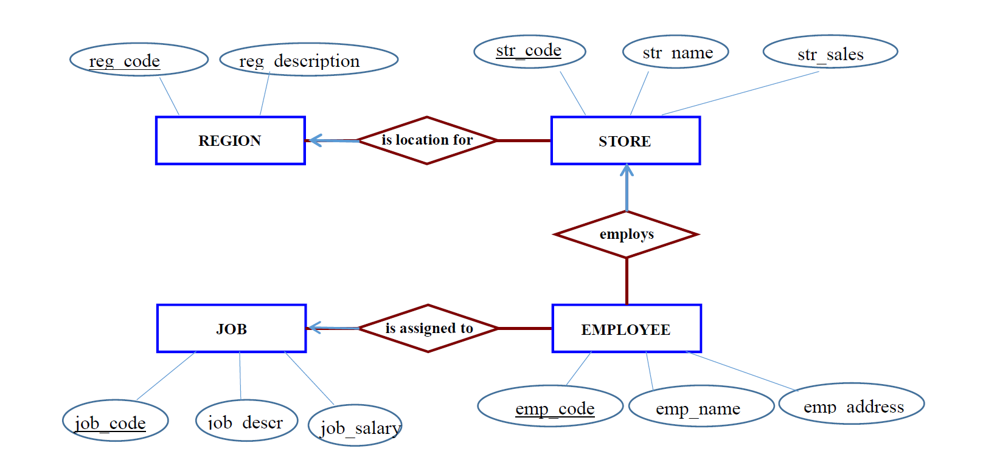

* 1. (5 Points) Identify all relationships, their cardinality. Write the corresponding business rules.
  2. (5 Points) Show the relational schema for the database. Identify Relations (Tables), their

attributes (field names). Make sure to clearly indicate primary keys and foreign keys.

***Note:*** *Foreign keys are based on relationships between entities*

**Question 2: ERD design (10 Points)**

Although you always wanted to be an artist, you ended up being an expert on databases because you love to cook data and you somehow confused *database* with *data paste*. Your old love is still there, however, so you set up a database company, ArtBase, that builds a product for art galleries. The core of this product is a database with a schema that captures all the information that galleries need to maintain. Galleries keep information about artists, their names (which are unique), birthplaces, age, and style of art. For each piece of artwork, the artist, the year it was made, its unique title, its type of art (e.g., painting, lithograph, sculpture, photograph), and its price must be stored. Pieces of artwork are also classified into groups of various kinds, for example, portraits, still lifes, works by Picasso, or works of the 19th century; a given piece may belong to more than one group. Each group is identified by a name (like those just given) that describes the group. Finally, galleries keep information about customers. For each customer, galleries keep that person’s unique name, address, total amount of dollars spent in the gallery (very important!), and the artists and groups of art that the customer tends to like.

2.1) (5 Points) Draw the ER diagram for the database.

2.2) (5 Points) Convert the ERD to the relational schema to build a database. Make sure to clearly indicate primary keys and foreign keys.